Họ và tên: Cao Xuân Mai

MSSV: 1150070028

**Animation**

**Bài 1 – Animation từ XML, Bài tập 2: Sử dụng Animation từ code**

Ý tưởng kỹ thuật:

Khai báo hiệu ứng trong res/anim/*.xml, sau đó nạp bằng AnimationUtils.loadAnimation() và chạy với ImageView.startAnimation(...).

1) Thêm dependencies (dùng ViewPager2)

Mở app/build.gradle (Module: app) và thêm 1 dòng vào dependencies:

implementation("androidx.viewpager2:viewpager2:1.1.0")

Bấm Sync Now.

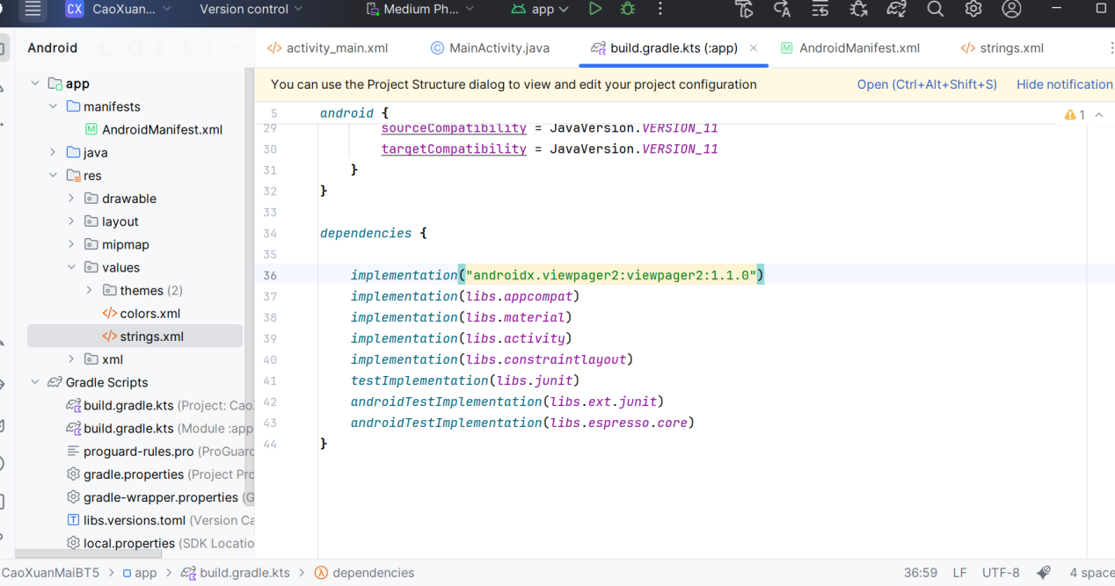

2) Khai báo 2 Activity bổ sung

Mở app/src/main/AndroidManifest.xml và thêm 2 activity (giữ nguyên activity mặc định

*<?*xml version="1.0" encoding="utf-8"*?>*<manifest xmlns:android="http://schemas.android.com/apk/res/android"  
 package="com.example.caoxuanmaibt5">  
  
 <application  
 android:allowBackup="true"  
 android:label="Lab06 Animation"  
 android:supportsRtl="true"  
 android:theme="@style/Theme.Material3.DayNight.NoActionBar">  
  
 <activity  
 android:name=".SlideActivity"  
 android:exported="false" />  
  
 <activity  
 android:name=".SecondActivity"  
 android:exported="false" />  
  
 <activity  
 android:name=".MainActivity"  
 android:exported="true">  
 <intent-filter>  
 <action android:name="android.intent.action.MAIN" />  
 <category android:name="android.intent.category.LAUNCHER" />  
 </intent-filter>  
 </activity>  
  
 </application>  
</manifest>

PHẦN B — Tạo tài nguyên giao diện (XML)

Bước B1 — Tạo chuỗi & kích thước

res/values/strings.xml:

<resources>  
 <string name="app_name">CaoXuanMaiBT5</string>  
 <string name="from_xml">From XML</string>  
 <string name="from_code">From CODE</string>  
 <string name="fade_in">Fade In</string>  
 <string name="fade_out">Fade Out</string>  
 <string name="blink">Blink</string>  
 <string name="zoom_in">Zoom In</string>  
 <string name="zoom_out">Zoom Out</string>  
 <string name="rotate">Rotate</string>  
 <string name="move">Move</string>  
 <string name="slide_up">Slide Up</string>  
 <string name="bounce">Bounce</string>  
 <string name="combine">Combine</string>  
 <string name="open_next">Open Next</string>  
 <string name="open_pager">Open ViewPager2</string>  
 <string name="hello">Hello, Animation!</string>  
</resources>

res/values/dimens.xml:

*<?*xml version="1.0" encoding="utf-8"*?>*<resources>  
 <dimen name="margin_base">5dp</dimen>  
 <dimen name="margin_basex2">10dp</dimen>  
 <dimen name="text_medium">16sp</dimen>  
 <dimen name="image_base">100dp</dimen>  
</resources>

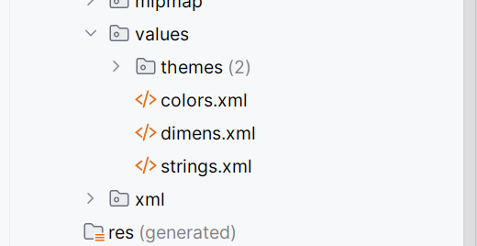

Bước B2 — Layout màn chính

res/layout/activity_main.xml

*<?*xml version="1.0" encoding="utf-8"*?>*<LinearLayout xmlns:android="http://schemas.android.com/apk/res/android"  
 xmlns:tools="http://schemas.android.com/tools"  
 android:layout_width="match_parent"  
 android:layout_height="match_parent"  
 android:orientation="vertical"  
 android:padding="8dp"  
 tools:context=".MainActivity">  
  
 <FrameLayout  
 android:layout_width="match_parent"  
 android:layout_height="0dp"  
 android:layout_weight="6">  
 <ImageView  
 android:id="@+id/iv_uit_logo"  
 android:layout_width="@dimen/image_base"  
 android:layout_height="@dimen/image_base"  
 android:layout_gravity="center"  
 android:scaleType="fitCenter"  
 android:src="@android:drawable/sym_def_app_icon"/>  
 </FrameLayout>  
  
 <LinearLayout  
 android:layout_width="match_parent"  
 android:layout_height="wrap_content"  
 android:orientation="horizontal"  
 android:layout_marginTop="@dimen/margin_basex2">  
 <TextView  
 android:layout_width="0dp"  
 android:layout_height="wrap_content"  
 android:layout_weight="1"  
 android:gravity="center"  
 android:textStyle="bold"  
 android:text="@string/from_xml"/>  
 <TextView  
 android:layout_width="0dp"  
 android:layout_height="wrap_content"  
 android:layout_weight="1"  
 android:gravity="center"  
 android:textStyle="bold"  
 android:text="@string/from_code"/>  
 </LinearLayout>  
  
 <ScrollView  
 android:layout_width="match_parent"  
 android:layout_height="0dp"  
 android:layout_weight="5">  
 <LinearLayout  
 android:layout_width="match_parent"  
 android:layout_height="wrap_content"  
 android:orientation="vertical">  
  
 *<!-- 10 hàng nút XML | CODE -->  
 <!-- H1 -->* <LinearLayout android:layout_width="match_parent" android:layout_height="wrap_content"  
 android:orientation="horizontal" android:layout_marginTop="@dimen/margin_base">  
 <Button android:id="@+id/btn_fade_in_xml" android:layout_width="0dp" android:layout_height="wrap_content" android:layout_weight="1" android:text="@string/fade_in"/>  
 <Button android:id="@+id/btn_fade_in_code" android:layout_width="0dp" android:layout_height="wrap_content" android:layout_weight="1" android:text="@string/fade_in"/>  
 </LinearLayout>  
 *<!-- H2 -->* <LinearLayout android:layout_width="match_parent" android:layout_height="wrap_content"  
 android:orientation="horizontal" android:layout_marginTop="@dimen/margin_base">  
 <Button android:id="@+id/btn_fade_out_xml" android:layout_width="0dp" android:layout_height="wrap_content" android:layout_weight="1" android:text="@string/fade_out"/>  
 <Button android:id="@+id/btn_fade_out_code" android:layout_width="0dp" android:layout_height="wrap_content" android:layout_weight="1" android:text="@string/fade_out"/>  
 </LinearLayout>  
 *<!-- H3 -->* <LinearLayout android:layout_width="match_parent" android:layout_height="wrap_content"  
 android:orientation="horizontal" android:layout_marginTop="@dimen/margin_base">  
 <Button android:id="@+id/btn_blink_xml" android:layout_width="0dp" android:layout_height="wrap_content" android:layout_weight="1" android:text="@string/blink"/>  
 <Button android:id="@+id/btn_blink_code" android:layout_width="0dp" android:layout_height="wrap_content" android:layout_weight="1" android:text="@string/blink"/>  
 </LinearLayout>  
 *<!-- H4 -->* <LinearLayout android:layout_width="match_parent" android:layout_height="wrap_content"  
 android:orientation="horizontal" android:layout_marginTop="@dimen/margin_base">  
 <Button android:id="@+id/btn_zoom_in_xml" android:layout_width="0dp" android:layout_height="wrap_content" android:layout_weight="1" android:text="@string/zoom_in"/>  
 <Button android:id="@+id/btn_zoom_in_code" android:layout_width="0dp" android:layout_height="wrap_content" android:layout_weight="1" android:text="@string/zoom_in"/>  
 </LinearLayout>  
 *<!-- H5 -->* <LinearLayout android:layout_width="match_parent" android:layout_height="wrap_content"  
 android:orientation="horizontal" android:layout_marginTop="@dimen/margin_base">  
 <Button android:id="@+id/btn_zoom_out_xml" android:layout_width="0dp" android:layout_height="wrap_content" android:layout_weight="1" android:text="@string/zoom_out"/>  
 <Button android:id="@+id/btn_zoom_out_code" android:layout_width="0dp" android:layout_height="wrap_content" android:layout_weight="1" android:text="@string/zoom_out"/>  
 </LinearLayout>  
 *<!-- H6 -->* <LinearLayout android:layout_width="match_parent" android:layout_height="wrap_content"  
 android:orientation="horizontal" android:layout_marginTop="@dimen/margin_base">  
 <Button android:id="@+id/btn_rotate_xml" android:layout_width="0dp" android:layout_height="wrap_content" android:layout_weight="1" android:text="@string/rotate"/>  
 <Button android:id="@+id/btn_rotate_code" android:layout_width="0dp" android:layout_height="wrap_content" android:layout_weight="1" android:text="@string/rotate"/>  
 </LinearLayout>  
 *<!-- H7 -->* <LinearLayout android:layout_width="match_parent" android:layout_height="wrap_content"  
 android:orientation="horizontal" android:layout_marginTop="@dimen/margin_base">  
 <Button android:id="@+id/btn_move_xml" android:layout_width="0dp" android:layout_height="wrap_content" android:layout_weight="1" android:text="@string/move"/>  
 <Button android:id="@+id/btn_move_code" android:layout_width="0dp" android:layout_height="wrap_content" android:layout_weight="1" android:text="@string/move"/>  
 </LinearLayout>  
 *<!-- H8 -->* <LinearLayout android:layout_width="match_parent" android:layout_height="wrap_content"  
 android:orientation="horizontal" android:layout_marginTop="@dimen/margin_base">  
 <Button android:id="@+id/btn_slide_up_xml" android:layout_width="0dp" android:layout_height="wrap_content" android:layout_weight="1" android:text="@string/slide_up"/>  
 <Button android:id="@+id/btn_slide_up_code" android:layout_width="0dp" android:layout_height="wrap_content" android:layout_weight="1" android:text="@string/slide_up"/>  
 </LinearLayout>  
 *<!-- H9 -->* <LinearLayout android:layout_width="match_parent" android:layout_height="wrap_content"  
 android:orientation="horizontal" android:layout_marginTop="@dimen/margin_base">  
 <Button android:id="@+id/btn_bounce_xml" android:layout_width="0dp" android:layout_height="wrap_content" android:layout_weight="1" android:text="@string/bounce"/>  
 <Button android:id="@+id/btn_bounce_code" android:layout_width="0dp" android:layout_height="wrap_content" android:layout_weight="1" android:text="@string/bounce"/>  
 </LinearLayout>  
 *<!-- H10 -->* <LinearLayout android:layout_width="match_parent" android:layout_height="wrap_content"  
 android:orientation="horizontal" android:layout_marginTop="@dimen/margin_base">  
 <Button android:id="@+id/btn_combine_xml" android:layout_width="0dp" android:layout_height="wrap_content" android:layout_weight="1" android:text="@string/combine"/>  
 <Button android:id="@+id/btn_combine_code" android:layout_width="0dp" android:layout_height="wrap_content" android:layout_weight="1" android:text="@string/combine"/>  
 </LinearLayout>  
  
 <LinearLayout android:layout_width="match_parent" android:layout_height="wrap_content"  
 android:orientation="horizontal" android:layout_marginTop="12dp">  
 <Button android:id="@+id/btn_next_activity" android:layout_width="0dp" android:layout_height="wrap_content" android:layout_weight="1" android:text="@string/open_next"/>  
 <Button android:id="@+id/btn_open_pager" android:layout_width="0dp" android:layout_height="wrap_content" android:layout_weight="1" android:text="@string/open_pager"/>  
 </LinearLayout>  
  
 </LinearLayout>  
 </ScrollView>  
</LinearLayout>

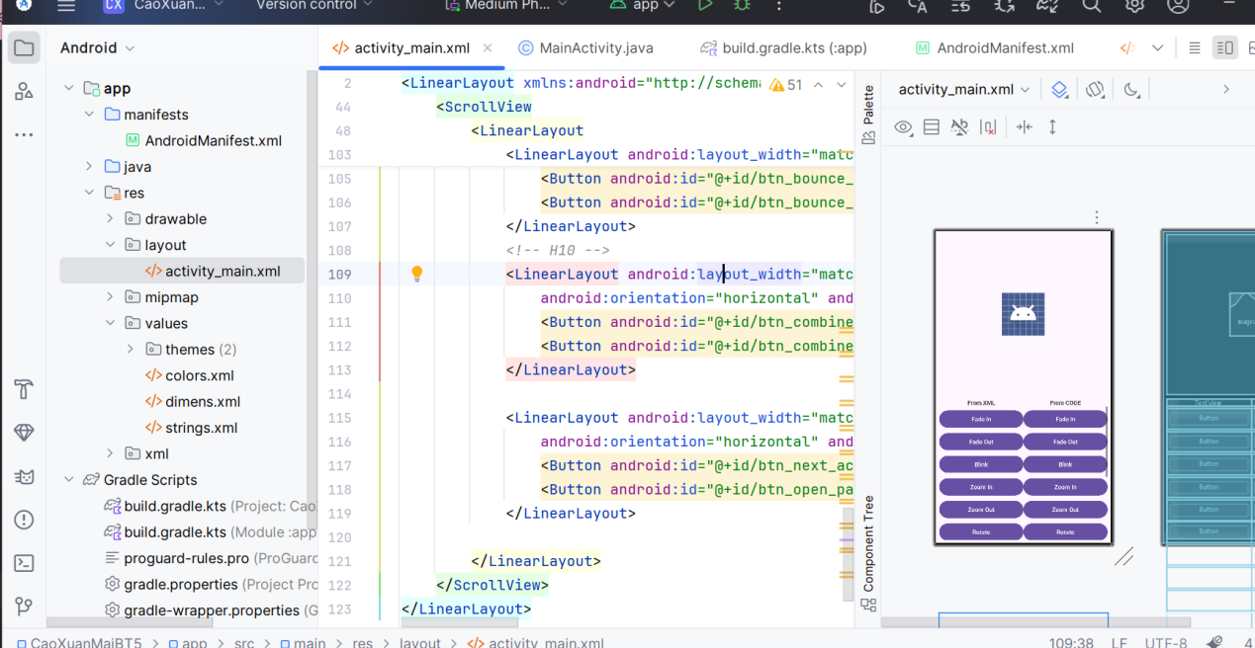

PHẦN C — Tạo 10 Animation XML

Tạo thư mục res/anim/ và thêm 10 file dưới đây :

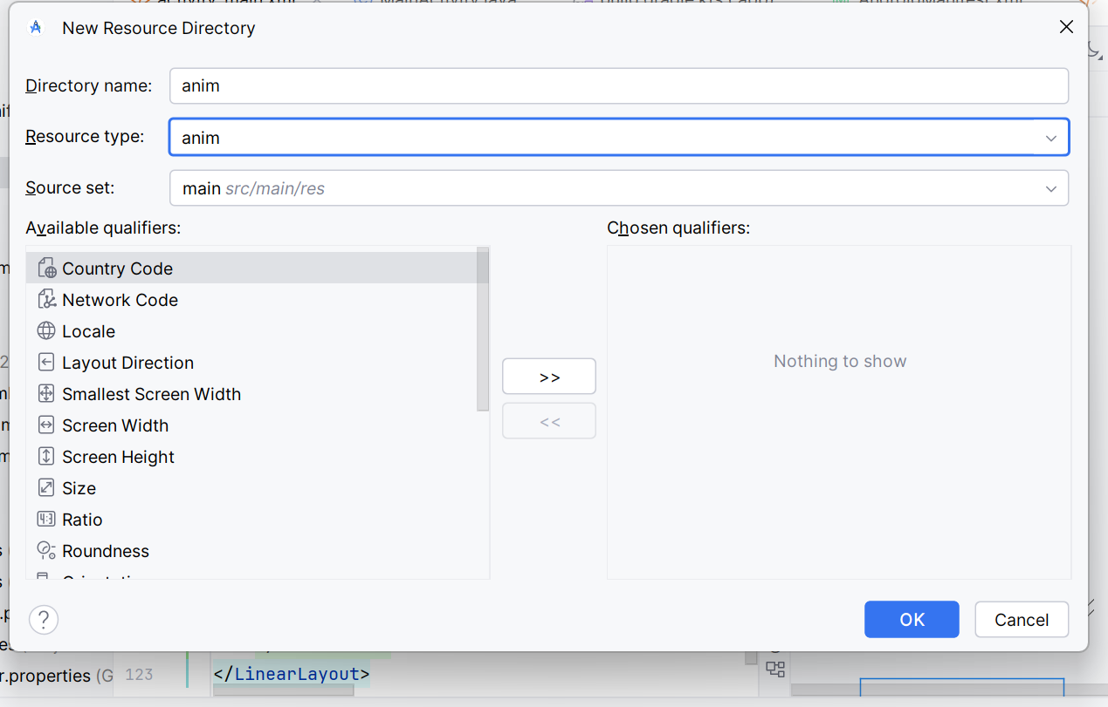

anim_fade_in.xml

*<?*xml version="1.0" encoding="utf-8"*?>*<set xmlns:android="http://schemas.android.com/apk/res/android" android:fillAfter="true">  
<alpha android:duration="1000" android:fromAlpha="0.0" android:toAlpha="1.0"/>  
</set>

anim_fade_out.xml

*<?*xml version="1.0" encoding="utf-8"*?>*<set xmlns:android="http://schemas.android.com/apk/res/android" android:fillAfter="true">  
 <alpha android:duration="1000" android:fromAlpha="1.0" android:toAlpha="0.0"/>  
</set>

anim_blink.xml

*<?*xml version="1.0" encoding="utf-8"*?>*<set xmlns:android="http://schemas.android.com/apk/res/android">  
 <alpha android:fromAlpha="0.0" android:toAlpha="1.0" android:duration="300"  
 android:repeatMode="reverse" android:repeatCount="3"/>  
</set>

anim_zoom_in.xml

*<?*xml version="1.0" encoding="utf-8"*?>*<set xmlns:android="http://schemas.android.com/apk/res/android" android:fillAfter="true">  
 <scale android:duration="1000" android:fromXScale="1" android:fromYScale="1"  
 android:pivotX="50%" android:pivotY="50%" android:toXScale="3" android:toYScale="3"/>  
</set>

anim_zoom_out.xml

*<?*xml version="1.0" encoding="utf-8"*?>*<set xmlns:android="http://schemas.android.com/apk/res/android" android:fillAfter="true">  
 <scale android:duration="1000" android:fromXScale="1.0" android:fromYScale="1.0"  
 android:pivotX="50%" android:pivotY="50%" android:toXScale="0.5" android:toYScale="0.5"/>  
</set>

anim_rotate.xml

*<?*xml version="1.0" encoding="utf-8"*?>*<set xmlns:android="http://schemas.android.com/apk/res/android">  
 <rotate android:fromDegrees="0" android:toDegrees="360" android:pivotX="50%" android:pivotY="50%"  
 android:duration="600" android:repeatMode="restart" android:repeatCount="2"  
 android:interpolator="@android:anim/cycle_interpolator"/>  
</set>

anim_move.xml

*<?*xml version="1.0" encoding="utf-8"*?>*<set xmlns:android="http://schemas.android.com/apk/res/android"  
 android:interpolator="@android:anim/linear_interpolator" android:fillAfter="true">  
 <translate android:fromXDelta="0%p" android:toXDelta="75%p" android:duration="800"/>  
</set>

anim_slide_up.xml

*<?*xml version="1.0" encoding="utf-8"*?>*<set xmlns:android="http://schemas.android.com/apk/res/android" android:fillAfter="true">  
 <scale android:duration="500" android:fromXScale="1.0" android:fromYScale="1.0"  
 android:toXScale="1.0" android:toYScale="0.0"/>  
</set>

anim_bounce.xml

*<?*xml version="1.0" encoding="utf-8"*?>*<set xmlns:android="http://schemas.android.com/apk/res/android" android:fillAfter="true"  
 android:interpolator="@android:anim/bounce_interpolator">  
 <scale android:duration="500" android:fromXScale="1.0" android:fromYScale="0.0"  
 android:toXScale="1.0" android:toYScale="1.0"/>  
</set>

anim_combine.xml

*<?*xml version="1.0" encoding="utf-8"*?>*<set xmlns:android="http://schemas.android.com/apk/res/android" android:fillAfter="true"  
 android:interpolator="@android:anim/linear_interpolator">  
 <scale android:duration="4000" android:fromXScale="1" android:fromYScale="1"  
 android:pivotX="50%" android:pivotY="50%" android:toXScale="3" android:toYScale="3"/>  
 <rotate android:duration="500" android:fromDegrees="0" android:toDegrees="360"  
 android:pivotX="50%" android:pivotY="50%" android:repeatCount="2" android:repeatMode="restart"/>  
</set>

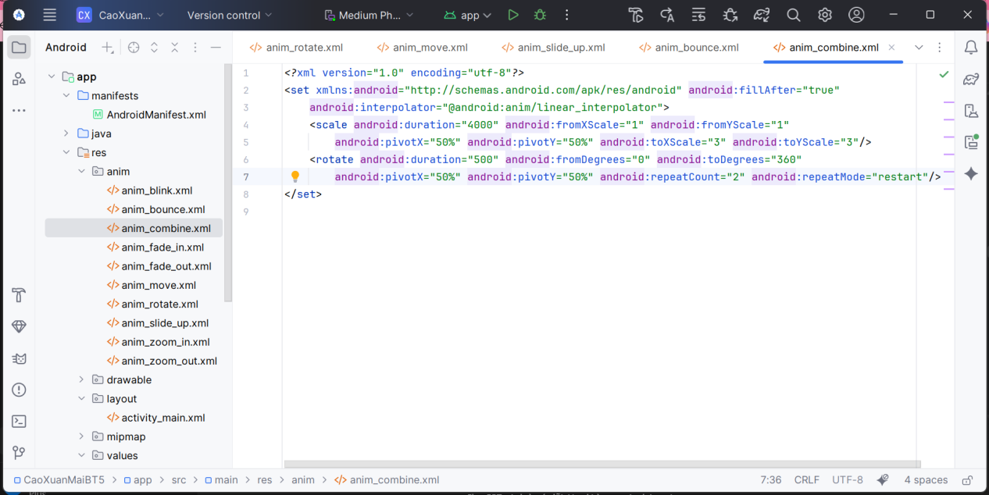

PHẦN D — Viết code điều khiển (Java)

Bước D1 — MainActivity.java

package com.example.caoxuanmaibt5;  
  
import android.content.Intent;  
import android.os.Bundle;  
import android.view.animation.*;  
import android.widget.Button;  
import android.widget.ImageView;  
import android.widget.Toast;  
import androidx.appcompat.app.AppCompatActivity;  
  
public class MainActivity extends AppCompatActivity {  
 private Button btnFadeInXml, btnFadeInCode, btnFadeOutXml, btnFadeOutCode,  
 btnBlinkXml, btnBlinkCode, btnZoomInXml, btnZoomInCode, btnZoomOutXml,  
 btnZoomOutCode, btnRotateXml, btnRotateCode, btnMoveXml, btnMoveCode,  
 btnSlideUpXml, btnSlideUpCode, btnBounceXml, btnBounceCode, btnCombineXml, btnCombineCode;  
 private Button btnNextActivity, btnOpenPager;  
 private ImageView ivUitLogo;  
 private Animation.AnimationListener animationListener;  
  
 @Override  
 protected void onCreate(Bundle savedInstanceState) {  
 super.onCreate(savedInstanceState);  
 setContentView(R.layout.*activity_main*);  
 findViewsByIds();  
 initVariables();  
  
 *// XML* handleClickAnimationXml(btnFadeInXml, R.anim.*anim_fade_in*);  
 handleClickAnimationXml(btnFadeOutXml, R.anim.*anim_fade_out*);  
 handleClickAnimationXml(btnBlinkXml, R.anim.*anim_blink*);  
 handleClickAnimationXml(btnZoomInXml, R.anim.*anim_zoom_in*);  
 handleClickAnimationXml(btnZoomOutXml, R.anim.*anim_zoom_out*);  
 handleClickAnimationXml(btnRotateXml, R.anim.*anim_rotate*);  
 handleClickAnimationXml(btnMoveXml, R.anim.*anim_move*);  
 handleClickAnimationXml(btnSlideUpXml, R.anim.*anim_slide_up*);  
 handleClickAnimationXml(btnBounceXml, R.anim.*anim_bounce*);  
 handleClickAnimationXml(btnCombineXml, R.anim.*anim_combine*);  
  
 *// CODE* handleClickAnimationCode(btnFadeInCode, buildFadeIn());  
 handleClickAnimationCode(btnFadeOutCode, buildFadeOut());  
 handleClickAnimationCode(btnBlinkCode, buildBlink());  
 handleClickAnimationCode(btnZoomInCode, buildZoom(1f, 3f));  
 handleClickAnimationCode(btnZoomOutCode, buildZoom(1f, .5f));  
 handleClickAnimationCode(btnRotateCode, buildRotate());  
 handleClickAnimationCode(btnMoveCode, buildMove());  
 handleClickAnimationCode(btnSlideUpCode, buildSlideUp());  
 handleClickAnimationCode(btnBounceCode, buildBounce());  
 handleClickAnimationCode(btnCombineCode, buildCombine());  
  
 btnNextActivity.setOnClickListener(v -> {  
 startActivity(new Intent(MainActivity.this, SecondActivity.class));  
 overridePendingTransition(android.R.anim.*fade_in*, android.R.anim.*fade_out*);  
 });  
  
 btnOpenPager.setOnClickListener(v -> {  
 startActivity(new Intent(MainActivity.this, SlideActivity.class));  
 overridePendingTransition(android.R.anim.*slide_in_left*, android.R.anim.*slide_out_right*);  
 });  
 }  
  
 private void findViewsByIds() {  
 ivUitLogo = findViewById(R.id.*iv_uit_logo*);  
 btnFadeInXml = findViewById(R.id.*btn_fade_in_xml*);  
 btnFadeInCode = findViewById(R.id.*btn_fade_in_code*);  
 btnFadeOutXml = findViewById(R.id.*btn_fade_out_xml*);  
 btnFadeOutCode= findViewById(R.id.*btn_fade_out_code*);  
 btnBlinkXml = findViewById(R.id.*btn_blink_xml*);  
 btnBlinkCode = findViewById(R.id.*btn_blink_code*);  
 btnZoomInXml = findViewById(R.id.*btn_zoom_in_xml*);  
 btnZoomInCode = findViewById(R.id.*btn_zoom_in_code*);  
 btnZoomOutXml = findViewById(R.id.*btn_zoom_out_xml*);  
 btnZoomOutCode= findViewById(R.id.*btn_zoom_out_code*);  
 btnRotateXml = findViewById(R.id.*btn_rotate_xml*);  
 btnRotateCode = findViewById(R.id.*btn_rotate_code*);  
 btnMoveXml = findViewById(R.id.*btn_move_xml*);  
 btnMoveCode = findViewById(R.id.*btn_move_code*);  
 btnSlideUpXml = findViewById(R.id.*btn_slide_up_xml*);  
 btnSlideUpCode= findViewById(R.id.*btn_slide_up_code*);  
 btnBounceXml = findViewById(R.id.*btn_bounce_xml*);  
 btnBounceCode = findViewById(R.id.*btn_bounce_code*);  
 btnCombineXml = findViewById(R.id.*btn_combine_xml*);  
 btnCombineCode= findViewById(R.id.*btn_combine_code*);  
 btnNextActivity = findViewById(R.id.*btn_next_activity*);  
 btnOpenPager = findViewById(R.id.*btn_open_pager*);  
 }  
  
 private void initVariables() {  
 animationListener = new Animation.AnimationListener() {  
 @Override public void onAnimationStart(Animation animation) {}  
 @Override public void onAnimationEnd(Animation animation) {}  
 @Override public void onAnimationRepeat(Animation animation) {}  
 };  
 }  
  
 private void handleClickAnimationXml(Button btn, int animId) {  
 btn.setOnClickListener(v -> {  
 Animation a = AnimationUtils.*loadAnimation*(getApplicationContext(), animId);  
 a.setAnimationListener(animationListener);  
 ivUitLogo.startAnimation(a);  
 });  
 }  
  
 private void handleClickAnimationCode(Button btn, final Animation animation) {  
 btn.setOnClickListener(v -> ivUitLogo.startAnimation(animation));  
 }  
  
 *// ===== CODE builders =====* private Animation buildFadeIn() {  
 AlphaAnimation a = new AlphaAnimation(0f, 1f);  
 a.setDuration(1000); a.setFillAfter(true); a.setAnimationListener(animationListener);  
 return a;  
 }  
 private Animation buildFadeOut() {  
 AlphaAnimation a = new AlphaAnimation(1f, 0f);  
 a.setDuration(1000); a.setFillAfter(true); a.setAnimationListener(animationListener);  
 return a;  
 }  
 private Animation buildBlink() {  
 AlphaAnimation a = new AlphaAnimation(0f, 1f);  
 a.setDuration(300); a.setRepeatMode(Animation.*REVERSE*); a.setRepeatCount(3);  
 a.setAnimationListener(animationListener);  
 return a;  
 }  
 private Animation buildZoom(float from, float to) {  
 ScaleAnimation s = new ScaleAnimation(from, to, from, to,  
 Animation.*RELATIVE_TO_SELF*, .5f, Animation.*RELATIVE_TO_SELF*, .5f);  
 s.setDuration(1000); s.setFillAfter(true); s.setAnimationListener(animationListener);  
 return s;  
 }  
 private Animation buildRotate() {  
 RotateAnimation r = new RotateAnimation(0f, 360f,  
 Animation.*RELATIVE_TO_SELF*, .5f, Animation.*RELATIVE_TO_SELF*, .5f);  
 r.setDuration(600); r.setRepeatMode(Animation.*RESTART*); r.setRepeatCount(2);  
 r.setAnimationListener(animationListener);  
 return r;  
 }  
 private Animation buildMove() {  
 TranslateAnimation t = new TranslateAnimation(  
 Animation.*RELATIVE_TO_PARENT*, 0f,  
 Animation.*RELATIVE_TO_PARENT*, .75f,  
 Animation.*RELATIVE_TO_PARENT*, 0f,  
 Animation.*RELATIVE_TO_PARENT*, 0f);  
 t.setDuration(800); t.setFillAfter(true); t.setAnimationListener(animationListener);  
 return t;  
 }  
 private Animation buildSlideUp() {  
 ScaleAnimation s = new ScaleAnimation(1f, 1f, 1f, 0f,  
 Animation.*RELATIVE_TO_SELF*, .5f, Animation.*RELATIVE_TO_SELF*, .5f);  
 s.setDuration(500); s.setFillAfter(true); s.setAnimationListener(animationListener);  
 return s;  
 }  
 private Animation buildBounce() {  
 ScaleAnimation s = new ScaleAnimation(1f, 1f, 0f, 1f,  
 Animation.*RELATIVE_TO_SELF*, .5f, Animation.*RELATIVE_TO_SELF*, .5f);  
 s.setDuration(500); s.setInterpolator(new BounceInterpolator());  
 s.setFillAfter(true); s.setAnimationListener(animationListener);  
 return s;  
 }  
 private Animation buildCombine() {  
 AnimationSet set = new AnimationSet(true);  
 set.setInterpolator(new LinearInterpolator());  
  
 ScaleAnimation s = new ScaleAnimation(1f, 3f, 1f, 3f,  
 Animation.*RELATIVE_TO_SELF*, .5f, Animation.*RELATIVE_TO_SELF*, .5f);  
 s.setDuration(4000);  
 set.addAnimation(s);  
  
 RotateAnimation r = new RotateAnimation(0f, 360f,  
 Animation.*RELATIVE_TO_SELF*, .5f, Animation.*RELATIVE_TO_SELF*, .5f);  
 r.setDuration(500); r.setRepeatCount(2); r.setRepeatMode(Animation.*RESTART*);  
 set.addAnimation(r);  
  
 set.setFillAfter(true); set.setAnimationListener(animationListener);  
 return set;  
 }  
}

**Bài 3 – Chuyển Activity có hiệu ứng**

Tạo SecondActivity + layout

activity_second.xml: TextView “Hello, Animation!”.

SecondActivity.java: gọi setContentView(...)

PHẦN E — Activity chuyển cảnh & ViewPager2

Bước E1 — SecondActivity

res/layout/activity_second.xml:

*<?*xml version="1.0" encoding="utf-8"*?>*<LinearLayout xmlns:android="http://schemas.android.com/apk/res/android"  
 android:orientation="vertical"  
 android:padding="16dp"  
 android:layout_width="match_parent"  
 android:layout_height="match_parent">  
  
 <TextView  
 android:layout_width="wrap_content"  
 android:layout_height="wrap_content"  
 android:text="Hello, Animation!"  
 android:textSize="24sp"  
 android:layout_gravity="center_horizontal"  
 android:layout_marginTop="24dp"/>  
  
 <Button  
 android:id="@+id/btnBack"  
 android:layout_width="wrap_content"  
 android:layout_height="wrap_content"  
 android:text="Back"  
 android:layout_gravity="center_horizontal"  
 android:layout_marginTop="16dp"/>  
</LinearLayout>

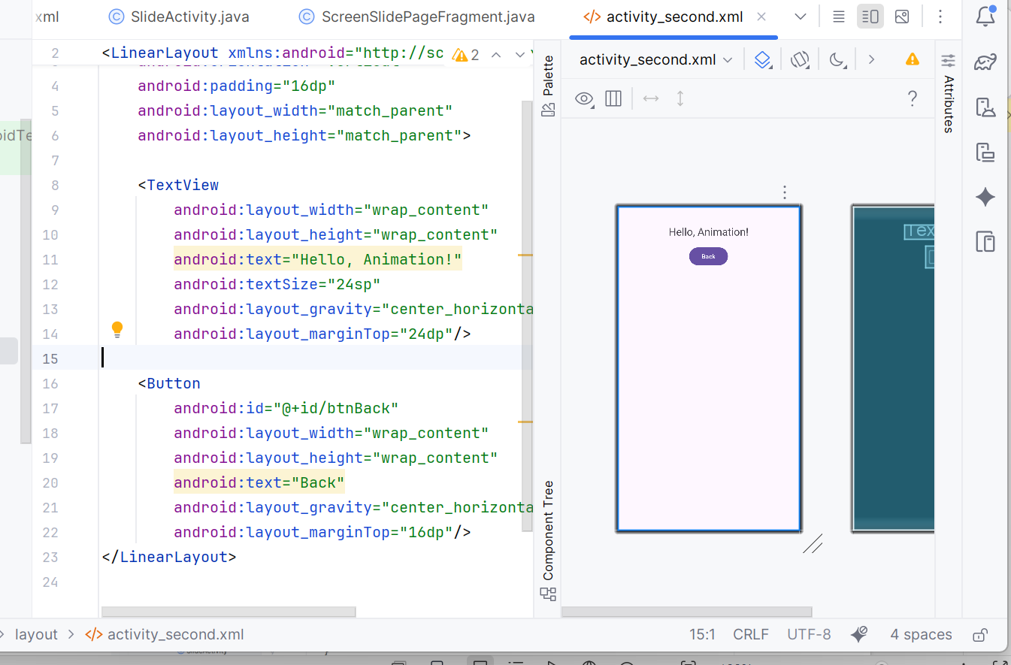

java/.../SecondActivity.java:

package com.example.caoxuanmaibt5;  
  
import android.os.Bundle;  
import androidx.appcompat.app.AppCompatActivity;  
  
public class SecondActivity extends AppCompatActivity {  
 @Override  
 protected void onCreate(Bundle savedInstanceState) {  
 super.onCreate(savedInstanceState);  
 setContentView(R.layout.*activity_second*);  
  
 findViewById(R.id.*btnBack*).setOnClickListener(v -> {  
 finish();  
   
 overridePendingTransition(android.R.anim.*slide_in_left*, android.R.anim.*slide_out_right*);  
 });  
 }  
   
 @Override  
 public void finish() {  
 super.finish();  
 overridePendingTransition(android.R.anim.*slide_in_left*, android.R.anim.*slide_out_right*);  
 }  
}

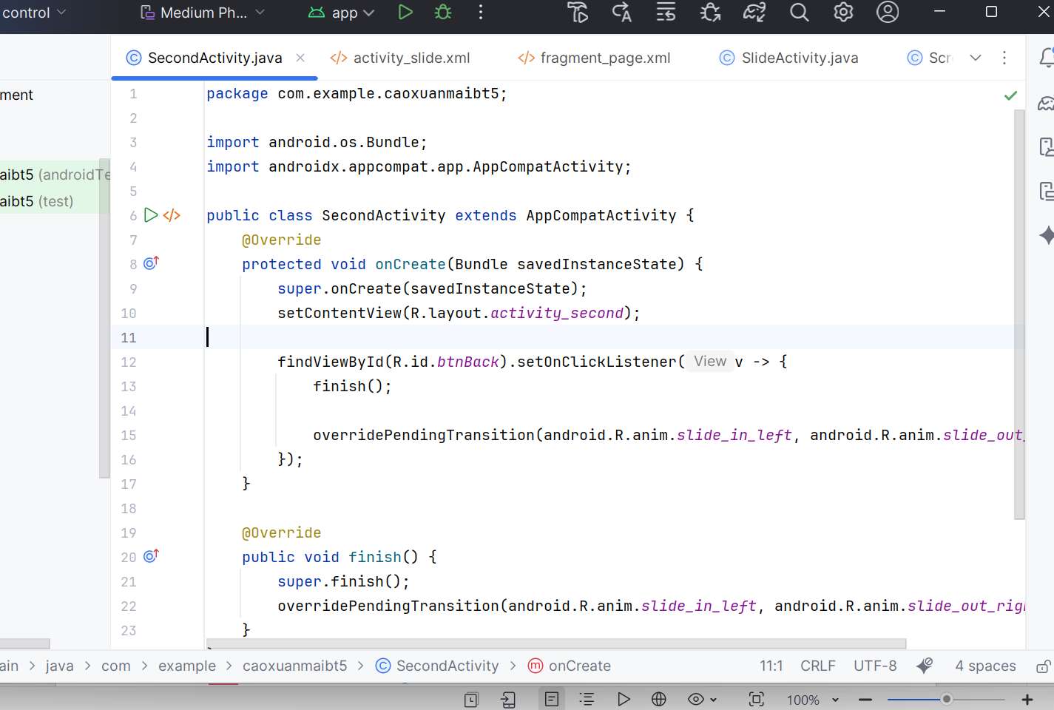

**Bài tập 4: Sử dụng ViewPager2 để tạo hiệu ứng xem vuốt giữa 2 fragments**

Bước E2 — ViewPager2

Tạo host & fragment

activity_slide.xml chứa ViewPager2.

SlideActivity.java set adapter:

res/layout/activity_slide.xml:

*<?*xml version="1.0" encoding="utf-8"*?>*<FrameLayout xmlns:android="http://schemas.android.com/apk/res/android"  
 android:layout_width="match_parent"  
 android:layout_height="match_parent">  
 <androidx.viewpager2.widget.ViewPager2  
 android:id="@+id/pager"  
 android:layout_width="match_parent"  
 android:layout_height="match_parent"/>  
</FrameLayout>

res/layout/fragment_page.xml:

*<?*xml version="1.0" encoding="utf-8"*?>*<FrameLayout xmlns:android="http://schemas.android.com/apk/res/android"  
 android:layout_width="match_parent"  
 android:layout_height="match_parent">  
 <TextView  
 android:id="@+id/tvPage"  
 android:layout_width="wrap_content"  
 android:layout_height="wrap_content"  
 android:text="Page"  
 android:textSize="28sp"  
 android:layout_gravity="center"/>  
</FrameLayout>

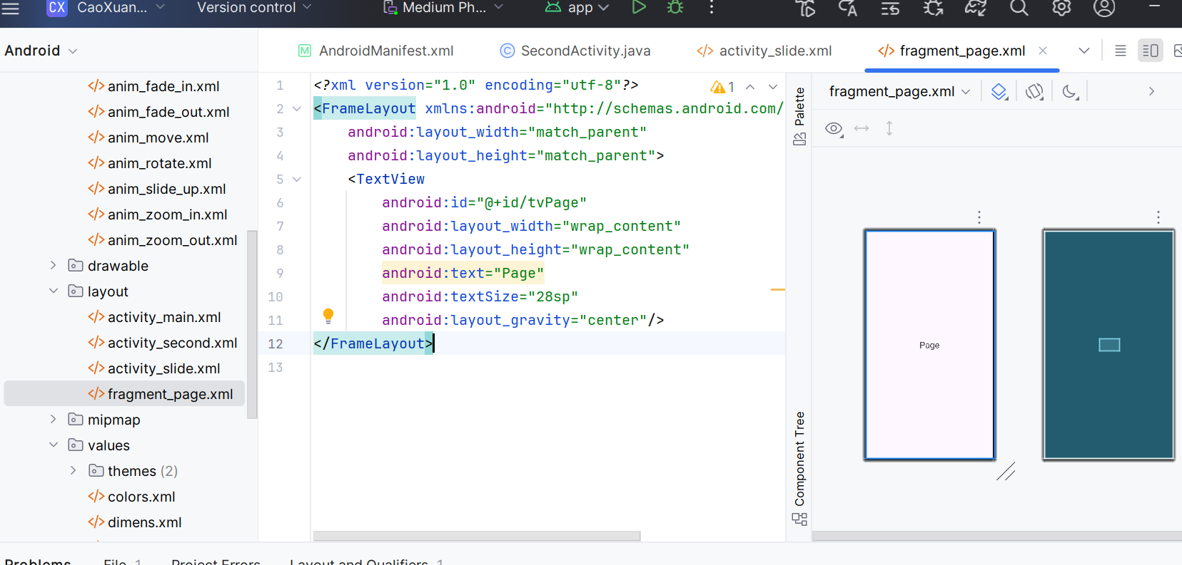

java/.../SlideActivity.java:

package com.example.caoxuanmaibt5;  
import android.os.Bundle;  
import androidx.annotation.NonNull;  
import androidx.appcompat.app.AppCompatActivity;  
import androidx.fragment.app.Fragment;  
import androidx.fragment.app.FragmentActivity;  
import androidx.viewpager2.adapter.FragmentStateAdapter;  
import androidx.viewpager2.widget.ViewPager2;  
  
public class SlideActivity extends AppCompatActivity {  
 @Override protected void onCreate(Bundle savedInstanceState) {  
 super.onCreate(savedInstanceState);  
 setContentView(R.layout.*activity_slide*);  
 ViewPager2 pager = findViewById(R.id.*pager*);  
 pager.setAdapter(new ScreenSlidePagerAdapter(this));  
 pager.setOrientation(ViewPager2.*ORIENTATION_HORIZONTAL*);  
 }  
 private static class ScreenSlidePagerAdapter extends FragmentStateAdapter {  
 public ScreenSlidePagerAdapter(@NonNull FragmentActivity fa) { super(fa); }  
 @NonNull @Override public Fragment createFragment(int position) {  
 return ScreenSlidePageFragment.newInstance(position);  
 }  
 @Override public int getItemCount() { return 2; }  
 }  
}

java/.../ScreenSlidePageFragment.java:

package com.example.caoxuanmaibt5;  
import android.os.Bundle;  
import android.view.*;  
import android.widget.TextView;  
import androidx.annotation.*;  
import androidx.fragment.app.Fragment;  
  
public class ScreenSlidePageFragment extends Fragment {  
 private static final String *KEY_INDEX* = "index";  
 public static ScreenSlidePageFragment newInstance(int idx) {  
 Bundle b = new Bundle(); b.putInt(*KEY_INDEX*, idx);  
 ScreenSlidePageFragment f = new ScreenSlidePageFragment(); f.setArguments(b);  
 return f;  
 }  
 @Nullable @Override  
 public View onCreateView(@NonNull LayoutInflater inflater, @Nullable ViewGroup container, @Nullable Bundle savedInstanceState) {  
 View v = inflater.inflate(R.layout.*fragment_page*, container, false);  
 TextView tv = v.findViewById(R.id.*tvPage*);  
 int idx = getArguments() != null ? getArguments().getInt(*KEY_INDEX*, 0) : 0;  
 tv.setText(idx == 0 ? "ViewPager2 — Trang 1" : "ViewPager2 — Trang 2");  
 return v;  
 }  
}

PHẦN F — Chạy thử, chụp hình & điền báo cáo

Bước F1 — Run & xác nhận

Nhấn Run.

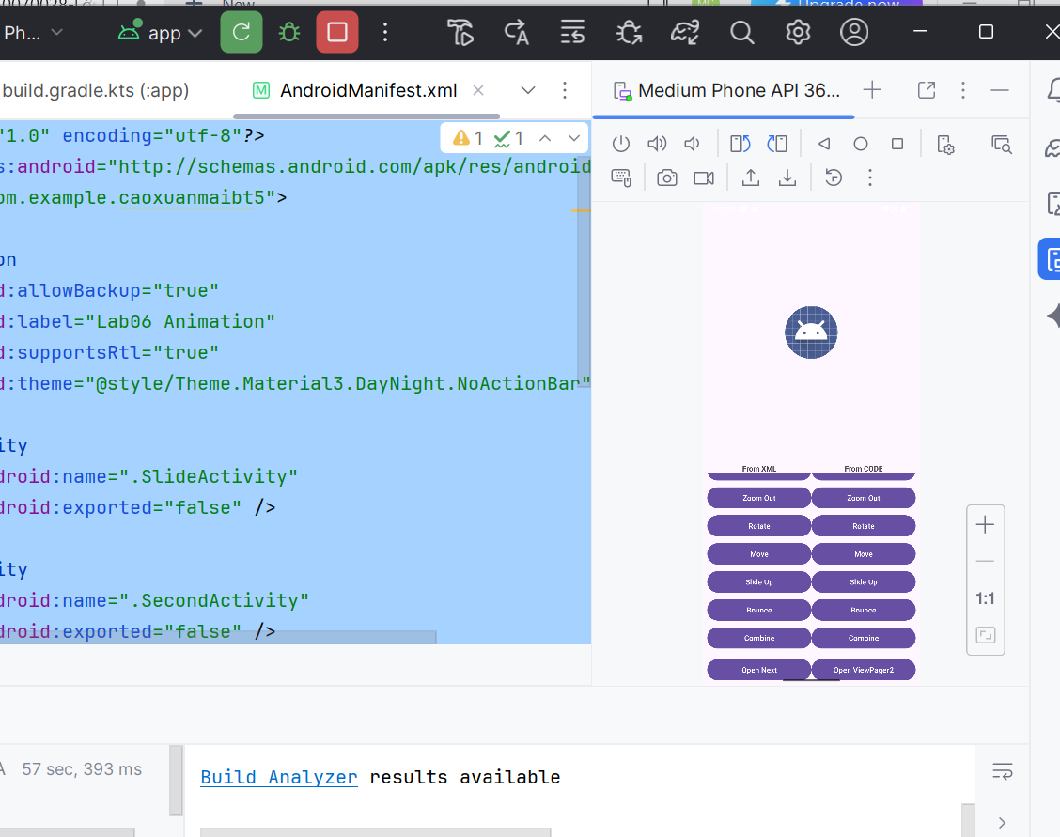

Trên màn chính: thử từng nút From XML (10 hiệu ứng), rồi From CODE (10 hiệu ứng).

Nhấn Open Next để thấy transition; Back để thấy hiệu ứng quay về.

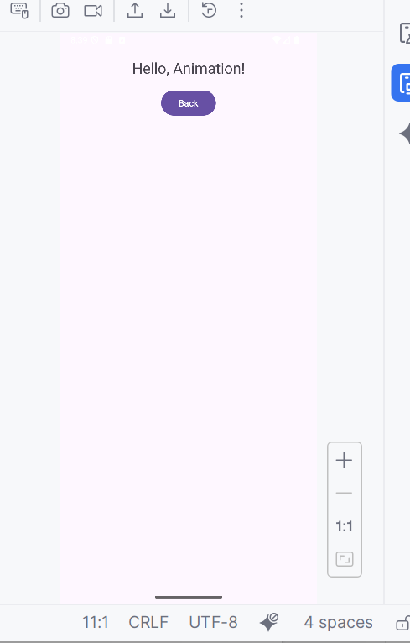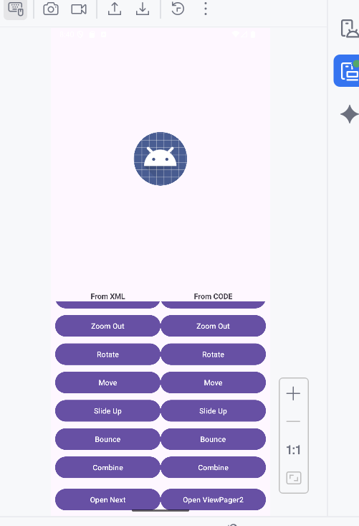

Nhấn Open ViewPager2 để vuốt 2 trang.

